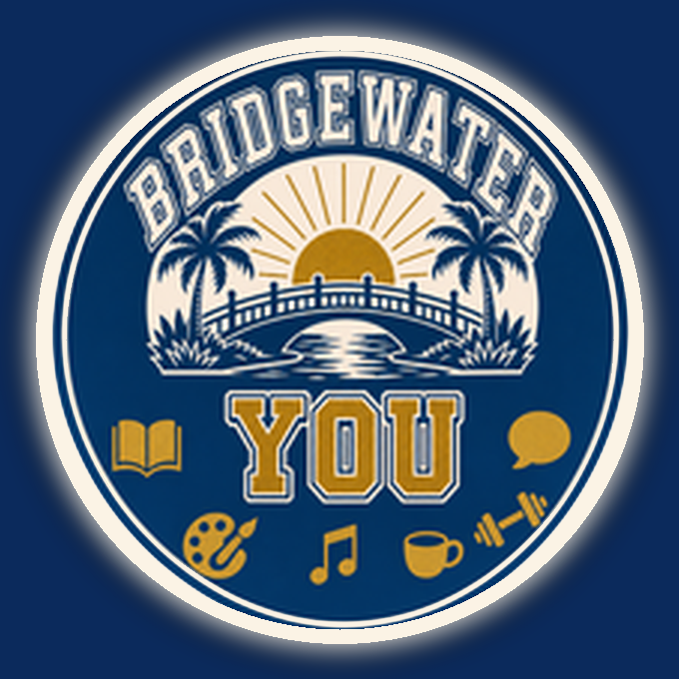 | CONNECTING FRIENDS · ENRICHING LIVES  BRIDGEWATER YOU  Winter ’27 Class Registration  Designed by Bridgewater Neighbors — For Bridgewater Neighbors
WINTER SEMESTER STARTS THE WEEK OF JANUARY 11, 2027

Welcome to Bridgewater YOU
Enjoy free classes and conversation taught by residents for residents — with no tests, no grades, and no pressure.
40+ FREE WINTER ’27 CLASSES & SEMINARS IN 6 CATEGORIES
Health & Safety  Lab Results, Balance 2, Holistic Care, Kidneys & Hearts, Self-Defense |  | History & Culture  Art History, Comparative Religions, Roaring 20s, Grand Canyon, Spanish
Science & Discovery  Fundamentals of AI, Astronomy, Math, Cosmology, Quantum & Space |  | Hobbies & Interest  Watercolor, Knitting, Bread Making, Dog Training, Backyard Birds, Fishing
Finances & Computers  Learn Your Smartphone, Online Safety & Scam Protection |  | Sports & Recreation  Beginning Bocce, Intermediate Pickleball, Ping Pong 101

WINTER ’27 SEMESTER · JANUARY – MARCH 2027  REGISTER ONLINE TODAY  https://bridgewateryou.net/registration | 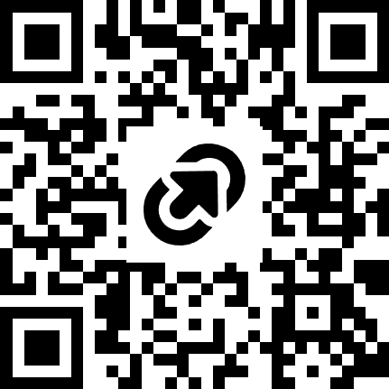
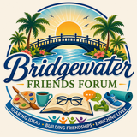 A BRIDGEWATER FRIENDS FORUM PROGRAM

